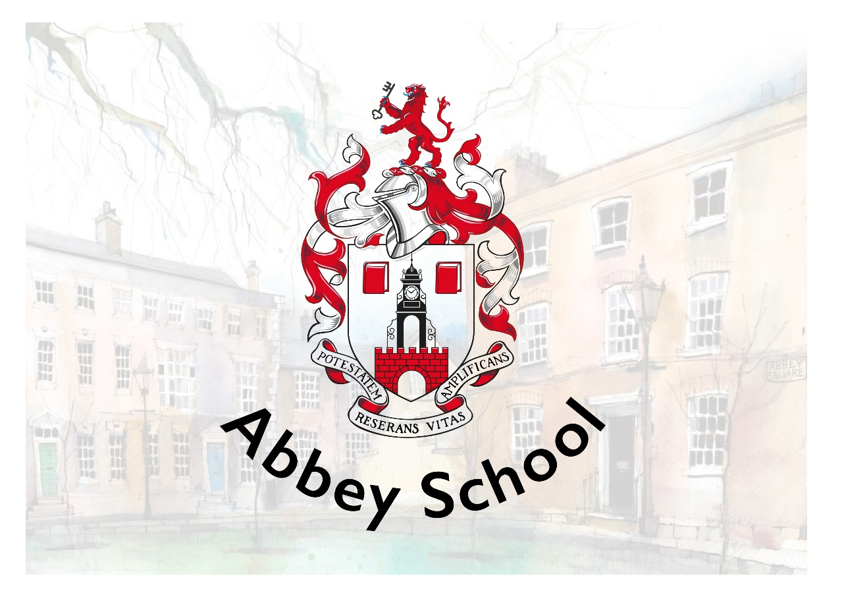

RECRUITMENT PACK
Learning Mentor

Abbey School
10-12 Abbey Square
Chester, CH1 2HU
recruitment@abbeyschool.com
01244 960000

CONTENTS

Welcome from the Principal 3
About our School 4
Job Description & Person Specification 6
Benefits 11
How to Apply 12
Shortlisting and Interviews 12
Start Date 12
Safeguarding Statement 13
Equal Opportunities Statement 13
Working in Chester 14

Welcome from the Principal

Welcome and thank you for your interest in Abbey School.
Our Independent Special School provides a unique environment of high-quality, evidence-informed education, nurture and care to young people aged 4-19 with autism whom may have additional learning difficulties and behaviours that challenge. We offer a comprehensive programme of support which ensures that all of our pupils’ individual needs are met through highly personalised learning.
We are privileged to benefit from a truly wonderful location. Our school is housed in stunning Grade II* listed buildings, part of historic Abbey Square in the heart of the beautiful city of Chester. Our fantastic team of architects have designed a well-equipped and high-tech learning environment for us, whilst maintaining the beauty of the buildings and surroundings for our pupils to enjoy. We make full use of our environment and location with a creatively designed curriculum that includes focused learning and enrichment activities that support wellbeing. This enables all of our young people to experience growth, development and success.
Our highly skilled and specialist staff team includes teachers, learning and behaviour specialists, speech and language therapists and occupational therapists. This trans-disciplinary focus ensures that each pupil’s individual needs are understood, accurately planned for and closely monitored as part of day-to-day school practice.
I am extremely proud to be the Principal of Abbey School, a place where pupil-centred practice is the norm and where the voice of the young people we support and their families is central to all that we do. It really is a very special place to work and learn.
Yours sincerely
Dr. Katy Lee

About our School
Abbey School is an Independent Special School for people aged 4-19 with autism whom may have additional learning difficulties and behaviours that challenge. We provide high-quality education and care in our beautiful Grade II* listed buildings in the heart of Chester. All young people attending Abbey School have an Education, Health and Care Plan (EHCP) with school places commissioned and funded via local authorities. We work in close partnership with families and carers with support, information sharing and workshop opportunities available throughout the academic year.
Abbey School is aspirational for all of the young people that we support. This aspiration is captured in our vision, mission and values which are central to all that we do at Abbey School.
Vision
Our vision is that all children with exceptional needs receive a meaningful and fulfilling education that enables them to make their own choices about the direction of their adult lives.

Mission
Abbey School exists to provide the best education possible for young people with exceptional needs.
- Every pupil is a unique individual with potential
- Special educational needs and/or disability should not be a barrier to a valued lifestyle
- All children and young people without exception are entitled to access the best education and support available
- Best practices in education are evidence-based
- Teaching and learning decisions should be evidence-driven
- Clear goals make data-based decisions more numerous and effective
- Education is for everyone and for the whole of a person’s life
- Learning is enabling, empowering and extends the boundaries of autonomy
- If a pupil is not learning, it is the teaching that needs to change – the learner is always right
- Pupil voice should be heard and respected

Values
Our whole school approach brings together everything that is known from special education research and best practice to maximise pupil learning and wellbeing. We are an innovative learning organisation. Our day-to-day working practices routinely inform research, evaluation and development. We have a bespoke curriculum, designed by us, specifically to meet the needs of our pupils.

Each pupil’s journey through the curriculum is personalised. Approaches to teaching and learning are individualised, goal-based and precisely assessed. The curriculum is delivered by transdisciplinary teams who benefit from a high level and intensive internal training programme.

Our unique APPs support staff in planning and monitoring each pupil’s learning journey on a moment-to-moment basis. We are centrally located in the heart of the city which provides many opportunities for community-based learning, live skills development and supported work placements as young people get older.

Every decision we make is framed in the context of the Abbey School BAGS model:
B – Belonging and connection – being part of a community and having a network of valued relationships.
A – Autonomy and control – having influence over day-to-day and life defining matters.
G – Gifts and talents – doing even better the things that are done really well, and learning to do things that are important but may not be done at all.
S – Speaking, listening and a sense of self – communicating effectively in a variety of ways not just speech, and having an identity that defines who I really want to be.

Job Description & Person Specification
Job Title | Learning Mentor | Employer | Abbey School
Starting Salary | Actual starting salary £24,636 (FTE £30,775)  With annual incremental rises | Reporting to | Class Teacher/Senior Learning Mentor
Working Hours | Full time Monday - Friday  (Term-time only)  35 hours per week  08:45-16:45  1-hour unpaid break | Line Manages | N/A

The role of a Learning Mentor is to fully support pupils throughout all areas of school life, which includes delivering a highly personalised curriculum, supporting with personal care, promoting independence, supporting pupils at their snack and lunch breaks, and always ensuring safety.
Applicants must be at least 21 years of age due to the age range of our pupils being supported.

Role Purpose
- Work as part of a class team, under the direction of the class teacher and trans-disciplinary colleagues, to deliver effective and appropriate teaching, learning and behaviour support in all areas of school life underpinned by an evidence-based behavioural model of practice.
- Creating a positive learning environment, reflective of the school’s culture and ethos as set out in its curriculum purpose statement.
- Work with pupils both individually and in small groups supporting them to overcome barriers to learning, delivering teaching, providing positive behaviour support and delivering other focused interventions.
- Act as the key worker for one pupil, taking responsibility for coordinating their resources, monitoring their daily data, and advocating for them within team meetings.

Responsibilities and Role
Teaching and Learning
- Implement and support the teacher’s implementation of appropriate teaching and learning activities to achieve challenging learning objectives in all areas of the curriculum, appropriately tailored to meet the individual needs of all children or young people in the class.
- Work within Abbey School’s Positive Behaviour Policy and framework to improve the quality of children and young people’s lives; establishing appropriate behaviour for learning and helping them to work with other people.
- Support children and young people to experience positive wellbeing through appropriate learning and leisure activities and by creating a supportive ethos within the class.
- Establish productive working relationships with children and young people, acting as a role model, and setting high expectations.
- Support inclusion for children and young people through experiences in other schools, colleges and work experience schemes.
- Support educational visits to meet the needs and interests of the children and young people in the class.
- Work with other members of the team to create classroom and corridor displays that celebrate progress and support learning.
- Create and develop engaging and motivating learning resources.
- Organise and manage individualised learning resources and supports for key child.
- Contribute to developing the autonomy and voice of the young people in your class, providing consistent opportunities for choice and supporting formal assessments of pupil voice.
Assessment, Target Setting and Recording Progress
- Provide feedback to children and young people in relation to their progress and achievement, and support them where they can to assess their own learning.
- Maintain objective and accurate records and reports on achievement, progress and other matters, collating appropriate evidence and entering data into the school systems accurately and in a timely manner.
- Support the transdisciplinary team to prepare for Person Centred Reviews to ensure that achievements are celebrated and key issues raised, discussed and actions agreed.
- Contribute to behavioural assessments, including functional assessments.
- Contribute to the planning and development of comprehensive function based Positive Behaviour Support Plans and interventions, monitoring the effectiveness of plans through monitoring your key child’s data collection systems and analysis of the data. Flagging any issues or concerns to the trans-disciplinary team.

Partnership Working
- Support parents to contribute to their child’s learning and progress by sharing information through home/school communication channels.
- Liaise effectively with other professionals, through partnership and team working through a trans-disciplinary approach to design and implement learning programmes and Positive Behaviour Support plans and interventions for individuals and to ensure a rich and varied curriculum.
Personal and Professional Development and School Improvement
- Commitment to developing a clear knowledge of the Abbey School Model (ASM) and the evidence-based approaches that underpin it.
- Take a full and active part in professional development activities.
- Regularly attend any relevant training and development activities both within and outside school and to attend relevant meetings.
- Be a reflective practitioner.
- Take an active part in training and other development opportunities and apply what is learnt to improve teaching and learning.
- Participate in Abbey School’s Appraisal process.
- Contribute to training and development for colleagues, including supporting members of the team to complete external and internal CPD, including accredited courses.
- Contribute to reviewing and improving the curriculum.
- Attend meetings called by school.

Common Accountabilities and Dimensions within all Roles
- Demonstrate the vision and values of Abbey School in everyday practice, upholding the schools’ ethos at all times.
- Actively contribute to the culture of Abbey School as a learning organisation.
- Be responsible for ensuring that your own practice is consistent with Abbey School policies and procedures.
- Be responsible for your own effective professional communication, orally and in writing, to the right people at the right time.
- Be responsible for ensuring that your own responsibilities and accountabilities are clearly defined and understood and for managing your work and working proactively with your manager to that end.
- Be responsible for the health and safety of others using proactive and reactive approaches. This may include using positive handling techniques such as Team-Teach.
- Uphold Abbey School policies to protect and safeguard pupils and vulnerable adults in order to secure their health, safety and wellbeing.

- Support pupils with intimate care (such as toileting, nappy changing, dressing and feeding) provide support to pupils with medical conditions and the administration of medicine as required by the needs of the pupils.
- Ensure that any personal care offered to pupils maintains their dignity, promotes their independence and account of all relevant policies.
- Be responsible for ensuring that personal use of resources is efficient and effective and actively upholds Abbey School’s policies.
- Commitment to promoting equality and diversity through assuming personal responsibility for implementing the school’s policy on Equal Opportunities and inclusion for all staff and pupils.
- Support the Principal and Senior Leadership Team in managing and organising the school efficiently and effectively to ensure it meets the needs of all site users, including pupils, staff, parents and visitors and supports effective teaching, learning and support.
- This role involves engaging in regulated activity with children and adults, therefore the post is subject to an Enhanced DBS with barred lists check.

General

- To undertake any task in line with requirements of the role under the direction of the Principal.

Person Specification
Criteria | Essential | Desirable
Qualifications & training | - Five GCSEs or equivalent (including Maths and English). | - Knowledge of safeguarding and child protection.  - Positive Behaviour Support qualification or training.  - Educated to A-level or recognised childcare qualification.
Experience | - Experience of working with or caring for children or young people.  - SEN experience  - Proven ability to solve problems quickly and remain calm in a crisis situation. | - Experience of working with children or young people with autism or special educational needs in a school, or health and social care setting  - Experience of supporting children or young people with behaviour that challenges.  - Experience of working in a fast-paced dynamic environment.
Skills & knowledge | - Flexible attitude to work and adaptable to the needs of the school.  - Able to speak and write clearly and use functional Maths to support children and young people.  - Effective communication and interpersonal skills.  - Ability to build effective working relationships with pupils and colleagues.  - Effective team member.  - Confident user of technology and software.  - Willingness to provide intimate care as required. | - Demonstrable experience of understanding and a personal commitment to safeguarding and promoting the welfare of children and young people.
Personal qualities | - Demonstrates a personal commitment to safeguarding and promoting the welfare of children and young people.  - Holds high aspirations for children and young people with complex needs and is passionate about providing learning opportunities for them.  - Committed to equality and diversity.  - Committed to excellence.  - Committed to Positive Behaviour Support and evidence-based practice.  - Emotionally and physically resilient.  - Physically fit and active to meet the demands of the role.  - Commitment to continuous professional development.  - Reflective practitioner.
Other requirements: | Enhanced DBS plus children and adult barred list checks  Must be at least 21 years old

Benefits
- Competitive salary
- Suite of staff benefits including pension scheme
- Technology appropriate for your job
- Comprehensive staff training programme
- Access to WeCare which is a 24/7 online GP, mental health support service, get fit programme and much more.
- Access to MediCash program for wellbeing benefits
- The opportunity to shape and improve the life chances of pupils with a disability, and in so doing, extend the prospect of an improved quality of life for family members and others

How to Apply
If you feel like you have the right qualities to join our exciting, innovative and exceptional school then please complete the school application form with a letter addressed to the Principal. Please ensure that you provide details of your skills and experience necessary for this particular position in your letter or personal statement. Application forms and letters can be emailed to recruitment@abbeyschool.com or sent by post to Abbey School, 10-11 Abbey Square, Chester, CH1 2HU. Please be advised that we will only accept fully completed application forms.

Deadline
Applications are reviewed as they are received, and therefore we encourage you to complete an application form at your earliest convenience.

Shortlisting and Interviews
Selection methods will be objective, promote equality of opportunity and guard against bias in line with the Equality and Diversity policy. The School will shortlist applicants based on the relevance and applicability of their professional attributes and personal qualities specified by the role. Essential and desirable qualities are published in the Person Specification for this role.
The School will complete an online search for all shortlisted candidates. If any incidents or issues have happened that are publicly available online, the school may wish to explore this at interview.
The interview process may consist of two stages: Stage 1 will consist of a formal panel interview, and you may be invited for a second interview which will include a class observation.

Start Date
As soon as possible.
Abbey School is in a period of growth; we are increasing our staff teams to meet the needs of our pupils that are due to start with us. We are looking for suitable candidates to start at their earliest convenience.

Safeguarding Statement
Abbey School is committed to safeguarding and promoting the welfare and safety of all pupils and expects all staff and volunteers to share this commitment.
Applicants will be required to undergo child protection screening appropriate to the post, including checks with past employers and the Disclosure and Barring Service.
The safeguarding responsibilities of this post are to uphold Abbey School policies to protect and safeguard pupils and vulnerable adults in order to secure their health, safety and wellbeing.
The post is exempt from the Rehabilitation of Offenders Act 1974 and the School is therefore permitted to ask job applicants to declare all convictions and cautions (including those which are ‘spent’ unless ‘protected’ under the DBS filtering rules) in order to assess their suitability to work with children.
Our Safeguarding Policy can be found on our Policies page on our website.

Equal Opportunities Statement
We are an equal opportunities employer and welcome applications from all suitably qualified persons regardless of their age, disability, gender reassignment, race, sex, pregnancy and maternity, marriage/civil partnerships, religion/belief, or sexual orientation.

Working in Chester
Abbey School is situated in the beautiful surroundings of Abbey Square, located in the heart of historic Chester.
Chester has often been ranked as one of the best places to live in the UK with many good schools, thriving suburbs, a vibrant independent restaurant scene and new, award-winning cultural centre Storyhouse. It has good rail and motorway connections to major cities and the coast.
Chester is suitable for families and singles or couples with a good choice of city-centre accommodation and villages or suburbs within close commuting distance. To find an Estate Agent for sales or lettings in Chester visit Best Estate Agent Guide.
For further information about living in Chester, please visit the Tourist Information website .
How to Find Us
We are located in Abbey Square next to Chester Cathedral, off Northgate Street.
By Public Transport
We promote sustainable travel and recommend that public transport is used where possible. Chester train station is a 5-10 minute walk away and is served by the following rail companies Merseyrail, Avanti West Coast, Transport for Wales and Northern Rail. For Park and Ride information visit the Cheshire West and Chester council information page.
Parking
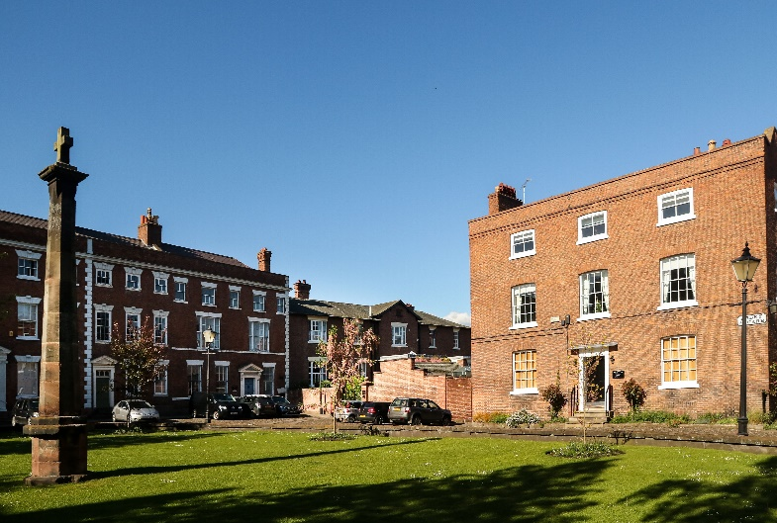
Visit the tourist information site for details of city centre car parks.

